# Greece – Source URL Analysis

**Source URL**: <https://et.gr/>

For ease of reading, all examples appearing in screenshots or metadata references have been translated into English.

The URL <https://www.hellenicparliament.gr/en/Nomothetiko-Ergo/Anazitisi-Nomothetikou-Ergou> was initially approved for extracting ESG legislations. However, upon further analysis, it was determined that the site does not contain the specific legislation required for our scope. Most of the relevant laws are either missing or not easily accessible from this source. We instead used the official gazette website of Greece. This approach allows us to capture all applicable ESG legislation.

## Overview

Government Gazette of Greece (ΦΕΚ) is the official journal for publishing all national legislation, decrees, regulations, international agreements, and legal instruments.

The platform has an [eService search](https://search.et.gr/el/) options, and we used the Smart Search for the search and extraction of relevant ESG legislation. It only provides search results with links to full text documents as downloadable PDF format.

## Extraction of Metadata

Before initiating the search, we first configured the filter options by clicking “Applying Filters” to refine the results.

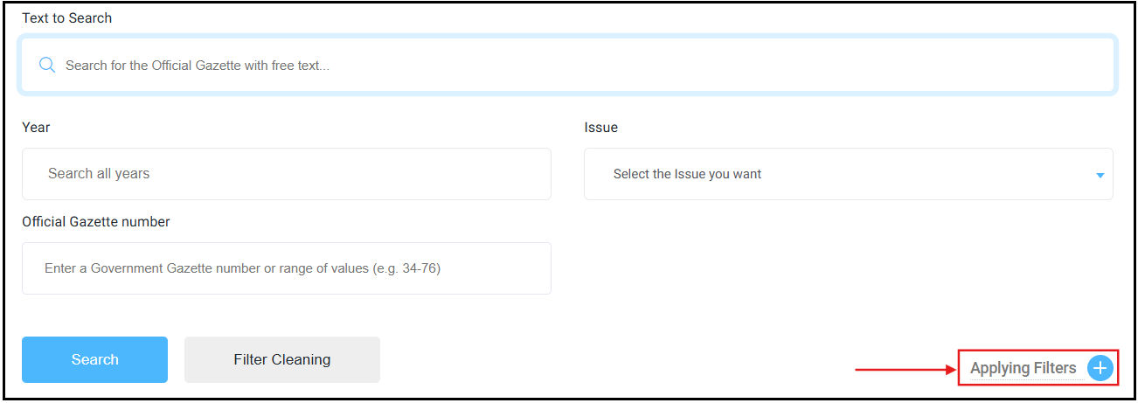

We specifically set the Entity Type filter to “Law” to focus exclusively on legislative acts. This helped ensure that the search results were relevant and targeted strictly to formal laws pertaining to ESG matters.

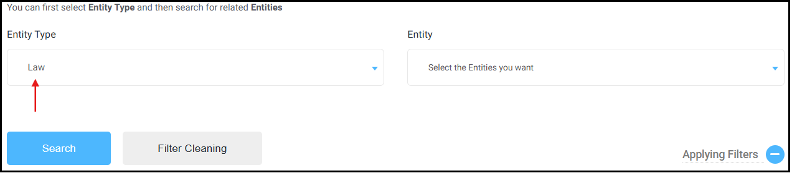

Greek keywords were then entered into the “Text to Search” field using quotation marks to perform exact match queries. For example, entering “Εθνικός Κλιματικός Νόμος” (national climate law) returned [109 results](https://search.et.gr/el/advanced-search/?advancedSearch=%2522%25CE%2595%25CE%25B8%25CE%25BD%25CE%25B9%25CE%25BA%25CF%258C%25CF%2582%2520%25CE%259A%25CE%25BB%25CE%25B9%25CE%25BC%25CE%25B1%25CF%2584%25CE%25B9%25CE%25BA%25CF%258C%25CF%2582%2520%25CE%259D%25CF%258C%25CE%25BC%25CE%25BF%25CF%2582%2522&selectedEntities=JTVCJTVE). The search results are displayed in a structured table format.

The required metadata is readily available in the search results list, from which we extracted the information as follows:

* **Source Link** – retrieved from the hyperlink embedded in the download icon within the Download column, labeled in red.

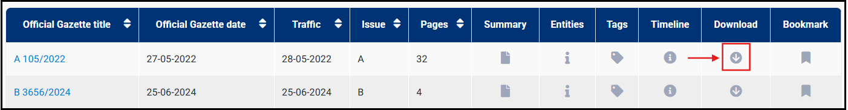

* **Original Title** – extracted by clicking the document icon within the Summary column, labeled in red.

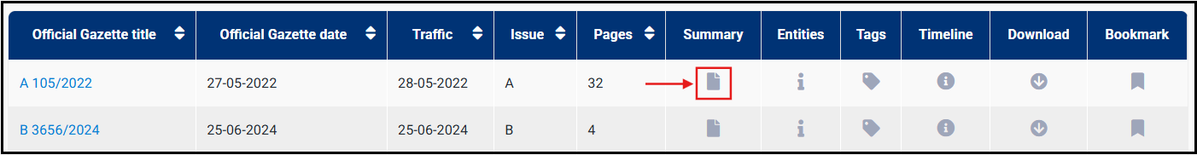

The original title was extracted from the sentence ending with a period, as shown below.

* **Type of Regulation** – as the Entity Type was set to “Law” during filtering, all extracted legislation is automatically categorized as “Law”.
* **Date of Adoption** – inferred from the Official Gazette date, labeled in blue.

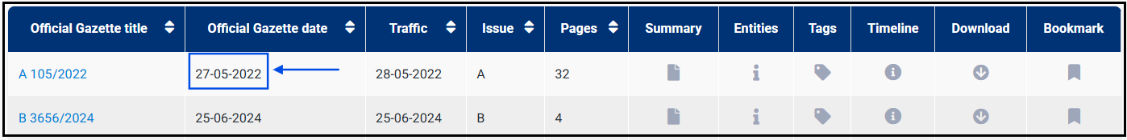

For KLI: Can you please confirm if this is acceptable?

* **Entry into Force** – inferred from the Traffic date, labeled in purple.

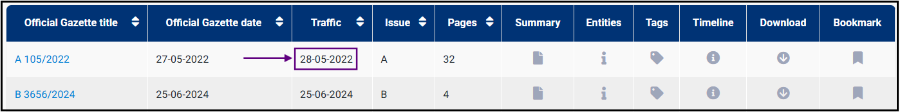

For KLI: Can you please confirm if this is acceptable?